Java script

>> Throttling
A function is called at most once in a specific time interval , no matter how many times the
Event is called
function Throttling ( fn , delay) {
let timer =false
return function (...args){
if(!timer){
fn.apply(this, args)
timer =true

timer= setTimeout(()=>{
timer=false
},delay)

}
}
}
const thr = Throttling (()=> {console.log("sunil")} ,2000)

const id =setInterval(()=>{
thr()
},200)

// If you ever want to stop the interval:
setTimeout(() => clearInterval(id), 6000);

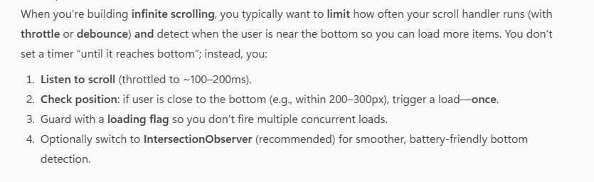
Ex: scrool
>> debouncing
a function is called only once after a specific time has passed since event is called
ex: calling api after search bar type

function debounce(fn, delay) {
let timeoutId;

return function (...args) {
clearTimeout(timeoutId); // Cancel previous timer
timeoutId = setTimeout(() => {
fn.apply(this, args); // Call after delay
}, delay);
};
}

function hifunc() {
console.log("hiiiiiiii");
}

const debouncedHi = debounce(hifunc, 1000);

debouncedHi()
debouncedHi()
debouncedHi()
debouncedHi()

>>Object.frozen()
Object.freeze() is a method that makes an object immutable — meaning you cannot change, add, or delete its properties after it's frozen.

>>Object.seal()
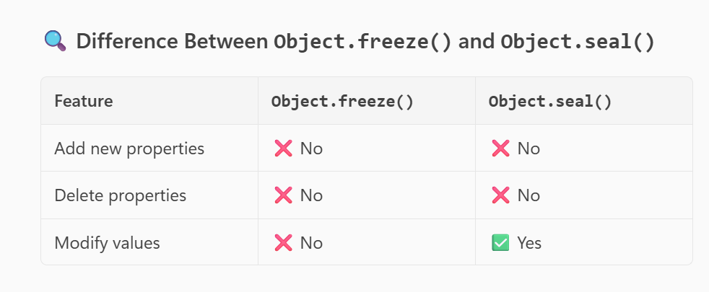

>> data types (primitive(Immutable (cant change), bul und nn str) and non primitive (mutable can change , AOF )
Primitive is pass by value
Non primitive is pass by reference
Data typers : nnssbbu

>> hoisting
The declaration (var x) of var and function move to top scope .
But assign do not move
>>Var get undefined
>>Let get reference error
>> == .===
>diff var , let and const
Var is function scope , can be re-assigned and re-decade . hoisting is done
let is block scope , can be re-assigned and but not re-decade . hoisting not done
const is block scope , can not be re-assigned and not re-decade . hoisting not done

>> Temporal Dead Zone ( in Let)
The Temporal Dead Zone is the time between when a variable is declared and when it is initialized, during which accessing the variable will throw an error.

>> coercion
Using operators to change the datatype

>> optional chaining
Data?.adress?.door

>> Nullish Coalescing Operator.
It returns the right-hand value if the left-hand value is null or undefined (not for other falsy values like 0, false, or "").

let name = null;
let displayName = name ?? "Guest";
console.log(displayName); // "Guest"

>> javascript is dynamically typed lang because it is check variable in RUN TIME
-----------Static typed check wile compile time

>> Immediately Invoked Function Expression (IIFE)
“An IIFE (Immediately Invoked Function Expression) is a function that runs as soon as it's defined. It helps create a private scope and is commonly used to avoid variable conflicts in global scope.”

(function () {
console.log("hello");
})();

>>> Strict mode
make JavaScript code run in a safer and cleaner way by catching common mistakes and preventing unsafe actions.

>> HOC
A Higher-Order Component (HOC) is a function that takes a component as input and returns a new component with added functionality.
• Authentication check
• API data fetching
• Logging user actions

>> HOC functon for I18n
import React from "react"
// to set an traslation object
const traslations ={
en:{
great:"hello"
},
hi:{
great:"नमस्ते"
}
}
//HOC
function withtraslation(WrappedComponent , lang ="en") {
return function transcomponet(props) {
const t = (key) => traslations[lang][key] || key
return <WrappedComponent t={t} />
}
}
export default withtraslation
>>compont
import React from 'react'
import withtraslation from "./Child" // import hoc//add t prop

const App = ({t}) => {
return (
<div>
<h1>{t("great")}</h1>
</div>
)}
// rap with HOC componet
export default withtraslation( App , "hi")

>>data fetch HOC
import React, { useEffect, useState } from 'react';
function withDataFetching(WrappedComponent, url) {
return function DataFetchingComponent(props) {
const [data, setData] = useState([]);
useEffect(() => {
fetch(url)
.then((res) => res.json())
.then((data) => setData(data))
}, [url]);
return <WrappedComponent data={data} />;
};}
export default withDataFetching;
// App.js
import React from 'react';
import withDataFetching from './Child'; // import and user prop
const App = ({ data }) => {
return (
<div>
<h1>Fetched Data</h1>
<div>
{data ? (data.map((item)=>(
<div key={item.id}>
{item.title}
</div>
))):( <p>loding......</p> )}
</div>
</div> )};
export default withDataFetching(App, 'https://jsonplaceholder.typicode.com/posts');

const withAuth = (WrappedComponent) => {
return function AuthComponent(props) {
const isLoggedIn = localStorage.getItem("token");
if (!isLoggedIn) {
return <h2>Please login first</h2>;
}
return <WrappedComponent {...props} />;
};
};

>> this key word : Refers to object function on property
Call()
• What it does: Calls the function immediately.
• Arguments: First is the object to use as this, followed by arguments individually.
function introduce(language, hobby) {
console.log(`Hi, I'm ${this.name}. I speak ${language} and love ${hobby}.`);
}
const person = {
name: "Ravi"
};
introduce.call(person, "Hindi", "cricket");

Apply ()
• What it does: Also calls the function immediately, with this set to thisArg.
• Arguments: First is the object to use as this, second is an array of arguments.
introduce.apply(person, ["Kannada", "chess"]);

Bind()
• What it does: Returns a new function with this bound to thisArg. It does not call the function immediately.
• Use case: Useful when you want to call the function later with a specific this.
const person = {
name: "Asha",
};
function greet(greeting) {
console.log(`${greeting}, ${this.name}`);
}
const greetAsha = greet.bind(person);
greetAsha("Hello"); // Output: Hello, Asha

exec() >> regx to get searching pattern as result or empty
test() >> regx to get true an d false if tis present

>> Currying
Currying is a technique where a function with multiple parameters is converted into a chain of functions, each taking one parameter at a time.

/////For infinet arg
function add(total = 0){
return function (num){
if(num === undefined) return total
return add(total+num)
}}
console.log(add(3)(4)(5)())
---------------------
function add1(a){
return function(b){
return a+b
}}
console.log(add1(3)(4))
>>SCOPE
Block , global , functional

Scope chaining is the process of resolving variable references by searching through the nested scopes from the current scope outward to its parent scopes.
>> closure
concept that allows a function to access variables from its outer (enclosing) scope, even after that outer function has finished executing.
function closure (){
let count =0

return function (){
return count
}
}
const inc = closure()
console.log(inc())

>> prototype
which is an object that is used to attach properties and methods that should be shared across all instances

>>Callback function
A callback function is a function passed into another function as an argument , to perform some operation

function great (name , callback){
console.log(`${name} hello`)
callback()
}
function heloo(){
console.log("hiiiiiiiii")
}
great("sunil" , heloo)

Error
Synta error
Logial error

>>Memozation
Memoization is a form of caching that stores the results of function calls so that future calls with the same arguments can return the result instantly without recalculating.

Recursion is a process in which a function calls itself directly or indirectly to solve a smaller instance of the same problem.
>> flat array with flat methrod
function flaten(arr){
let result = arr.reduce((acc,val)=>(
Array.isArray(val) ? acc.concat(flaten(val)) : acc.concat(val) )
,[])
return result
}
console.log(flaten([1,3,4,[45,66],4566]))

>> add array without using loop or methods

>> Palindrome ( same from bothend)
const isPalindrome =(name)=>{
const name1= name.split("").reverse().join("")
return name == name1 ? true : false
}
console.log(isPalindrome("madam")); // true
console.log(isPalindrome("racecar")); // true
console.log(isPalindrome("hello")); // false
console.log(isPalindrome("racecar1")); // false

>>Constructor function : Use to create object
>> DOM (document object model) 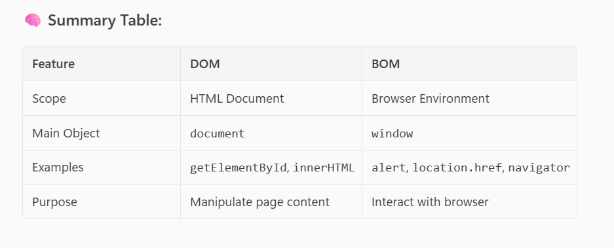
>>>Arraw function (es6)
• Shorter syntax
• it doesn’t have its owned THIS . if we use it target to parent scope
• Cannot be used as constructors (i.e., no new)
• No arguments object (use rest parameters instead)
const arrowFunc = (...args) => {
console.log(args); // ✅ works fine
};

arrowFunc(1, 2, 3); // Logs: [1, 2, 3]

>>>Rest and spread
spread […arr, …arr2} concat
Rest function (a, b , …rest) for destructing
Differ way to create obj
. object
. object constructer
.using function
Promise
programming construct used to handle the resolution or rejection of an asynchronous function in JavaScript.
const prom = async () => {
try {
const response = await fetch("https://api.example.com/data");
const data = await response.json();
return data;
} catch (error) {
console.log("Failed:", error);
}};
// To handle the Promise returned by the async function:
prom().then(data => {
console.log("Fetched data:", data);}); to call we should use

const prom = () => {
return new Promise((resolve, reject) => {
fetch("https://api.example.com/data")
.then(response => response.json())
.then(data => resolve(data))
.catch(error => reject(error));
});
};

prom()
.then(data => {
console.log("Fetched data:", data);
})
.catch(error => {
console.error("Error fetching data:", error);
});

classes is use to create constructer which was introduce in es6

genrater function
function that can be paused and resumed, allowing you to produce a sequence of values over time, rather than computing them all at once.

function* numberGenerator() {
yield 1;
yield 2;
yield 3;
}
const gen = numberGenerator();

console.log(gen.next()); // { value: 1, done: false }
console.log(gen.next()); // { value: 2, done: false }
console.log(gen.next()); // { value: 3, done: false }
console.log(gen.next()); // { value: undefined, done: true }

>>> Destructuring array
const arr = [1, 2, 3];
const [a, b, c] = arr
>>>object
const person = {
name: "Sunil",
age: 35,location: "Bangalore"};
const { name, age } = person;
>> nested
const {
name,
address: {
city,
country: { name: countryName, code }
}
} = user;

>>>>>. Lexical scope
means that a variable defined in a certain scope is available only within that scope and its inner (nested) scopes. The scope is determined at compile time, not at runtime.

>> Bubbling and Capturing
>>Capturing Phase (also called "capture" or "trickle down"):
- The event starts from the window and moves down through the DOM tree to the target element.
>> Bubbling Phase:
- The event then bubbles up from the target element back to the window, passing through its ancestors.

Es6 array methods
Froms() , find() , entries() , keys ()
String methors
Includes() , repeat()
Output od this
console.log([..."sunil"]) // [ 's', 'u', 'n', 'i', 'l' ]

Object.freeze() is a method used to make an object immutable
const person = {
name: "Sunil",
age: 30
};

Object.freeze(person);

person.age = 31; // ❌ No effect
person.city = "Bangalore"; // ❌ No effect
delete person.name; // ❌ No effect
console.log(person); // { name: "Sunil", age: 30 }

Object.seal(obj)
- Prevents new properties from being added to the object.
- Marks all existing properties as non-configurable, meaning:
  - You cannot delete properties.
  - You cannot change property descriptors (like configurable or enumerable).
- You can still modify the values of existing properties (if they are writable).
>>>Shallow Copy
Will change only in first stage not nested object.
const original = {
name: "Sunil",
address: {
city: "Bangalore"
}
};==
const shallowCopy = { ...original };
>>>> Deep Copy
const original = {
name: "Sunil",
address: {
city: "Bangalore"
}
};
// Deep copy using JSON methods
const deepCopy = JSON.parse(JSON.stringify(original));

deepCopy.address.city = "Mumbai";
console.log(original.address.city); // "Bangalore"
console.log(deepCopy.address.city); // "Mumbai"

OR
Const copy = structuredClone(original)

JSON.parse make just key and value pair

const jsonString1 = '{"name":"Sunil","age":30}';
const userObject = JSON.parse(jsonString1);
console.log(userObject); // Output: { name: 'Sunil', age: 30 }

JSON.stringify make all to string
const user = {
name: "Sunil",
age: 30
};
const jsonString = JSON.stringify(user);
console.log(jsonString);
// Output: '{"name":"Sunil","age":30}'

Event loop
Imagine a chef (call stack) cooking one dish at a time. If a dish needs to marinate (async task), the chef sets it aside (Web API), continues cooking other dishes, and comes back to it when it's ready (event loop brings it back).
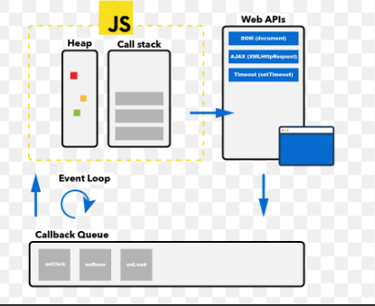

Cookies
• Store small pieces of data (like session IDs) that need to be sent to the server with every HTTP request.
• Size Limit: ~4 KB
• Access: document.cookie
• Use Case: Authentication tokens, user tracking.

Local Storage
- Purpose: Store data in the browser that persists even after the browser is closed.
- Size Limit: ~5–10 MB (varies by browser)
- • Access: localStorage.setItem(), getItem(), removeItem()
- • Use Case: Theme preferences, offline data, cart items.
- Clear in time slot or manually .

Session Storage
- Purpose: Store data for the duration of a page session (until tab is closed).
- Size Limit: Similar to local storage (~5 MB)
- • Access: sessionStorage.setItem(), getItem(), removeItem()
- • Use Case: Temporary form data, tab-specific state.
- Clear when session ends

display: block
- Takes full width of its container.
- Starts on a new line.
- You can set width, height, margin, and padding.
- Common block elements: <div>, <p>, <h1>–<h6>, <section>, <article>

display: inline
- Does not start on a new line.
- Only takes up as much width as its content.
- You cannot set width or height.
- Common inline elements: <span>, <a>, <strong>, <em>
Inline-Block Elements
- Behave like inline elements (do not break to a new line).
- But allow width and height to be set like block elements.
- Useful for creating layouts without breaking flow.

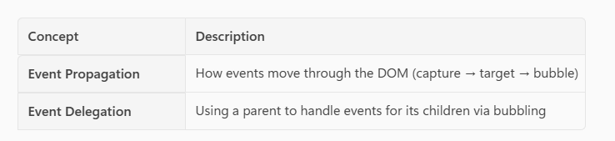
preventDefault() in JavaScript
The preventDefault() method is used to stop the default behavior of an event from happening.

prototype Inheritance
"Inheritance in JavaScript means that objects can access properties and methods from other objects through the prototype chain. “

"Arrays in JavaScript are special types of objects. They inherit from Array.prototype, which provides built-in methods like .push(), .pop(), .map(), and .filter()."

class MyArray extends Array {
sum() {
return this.reduce((a, b) => a + b, 0);
}
}

const nums = new MyArray(1, 2, 3);
console.log(nums.sum()); // 6
"Object.prototype

"Object.prototype is the top-level prototype in JavaScript. It provides default methods like toString(), hasOwnProperty(), and valueOf() that are inherited by all objects unless explicitly overridden.
When we access a property or method on an object, JavaScript looks for it on the object itself. If it’s not found, it moves up the prototype chain — and Object.prototype is usually the final link in that chain.

const person = {
name: "Alice",
age: 25
};

console.log(person.hasOwnProperty("name")); // true

Child to parent data transfer / and function transfer also
import React, { useState } from 'react'
import Child from './Child'
const App = () => {
const [func ,setfunc]= useState(null)
const datafun =(fn)=>{
setfunc(()=>fn)
}
return (
<div>
<Child datafun={datafun} />
<button onClick={func}>click</button>
</div>
)
}
export default App
------
import React, { useEffect } from 'react'
function Child({datafun}) {
const justfun =()=>{
alert("heloofunc")
}

useEffect(()=>{
datafun(justfun)
},[datafun])
return (
<div>
"child finn"
</div>
)
}
export default Child

curring infinet
Currying is a technique in JavaScript (and other languages) where a function is transformed so that it takes one argument at a time, instead of all arguments at once.

const add = (a)=>(b)=> b !== undefined ? add(a+b):a
console.log(add(10)(20)(30)())

stopPropagation
• Normally, clicking the button would trigger both handleChildClick and handleParentClick because of event bubbling.
• e.stopPropagation() prevents the event from reaching the parent.
When you want an event to be handled only at a specific level and not affect ancestors.
>>
e.preventDefault() → Stops the default browser behavior (e.g., form submission)
>>
e.nativeEvent.stopImmediatePropagation() → Stops other listeners on the same element.

>>Could you clarify what you mean by "suspicious function"? Are you referring to:
- A function in your code that seems incorrect or behaves unexpectedly?
- A malicious or unsafe function (e.g., in a security context)?
- A function that looks inefficient or buggy?
>> data structure of the Real DOM vs Virtual DOM:
>Real DOM (Document Object Model)
- Definition: The actual tree structure representing the HTML elements in the browser.
- Structure:
  - It is a tree of nodes where each node represents an element, attribute, or text.
>Virtual DOM
• Definition: A lightweight JavaScript object representation of the Real DOM used by libraries like React.
• Structure:
- A tree of JavaScript objects mimicking the DOM structure.

- Stack Memory: Stores static local variables and function call data is RAM
- Heap Memory: Stores dynamically allocated data (e.g., objects, arrays) in RAM

>>>>>>>>>>>>>>>Methodes

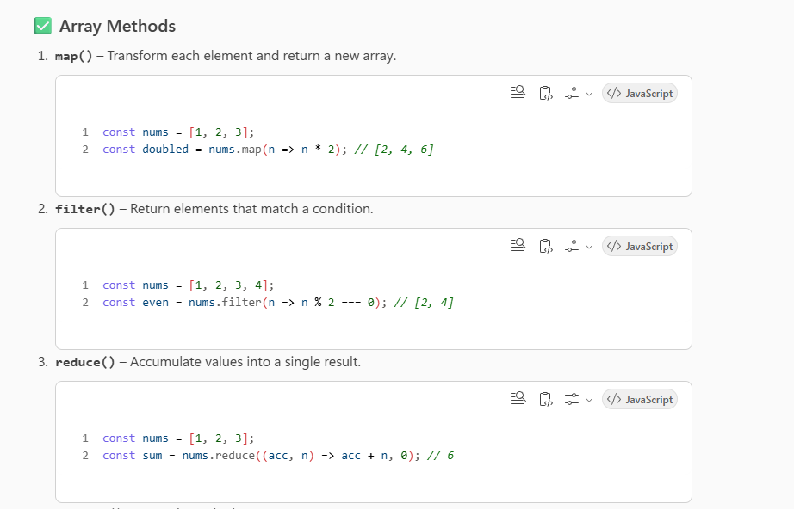
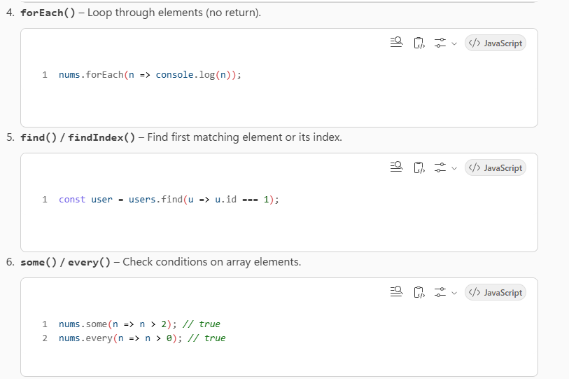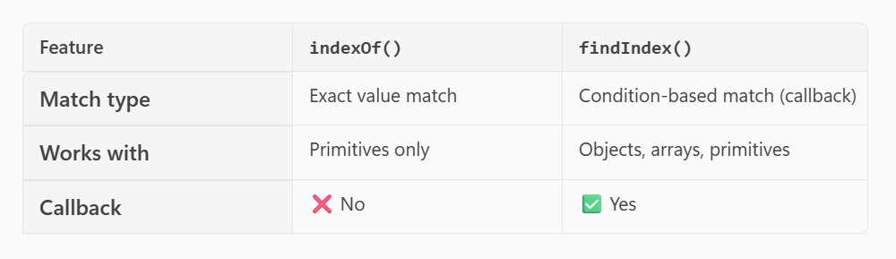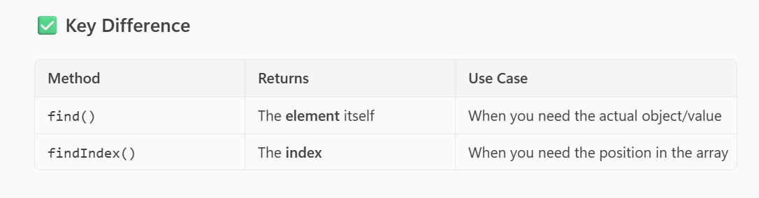
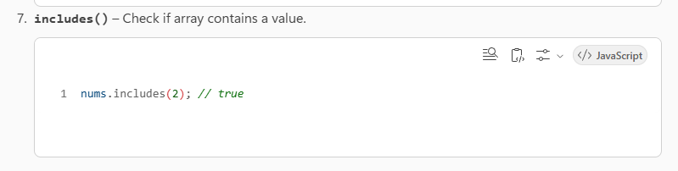

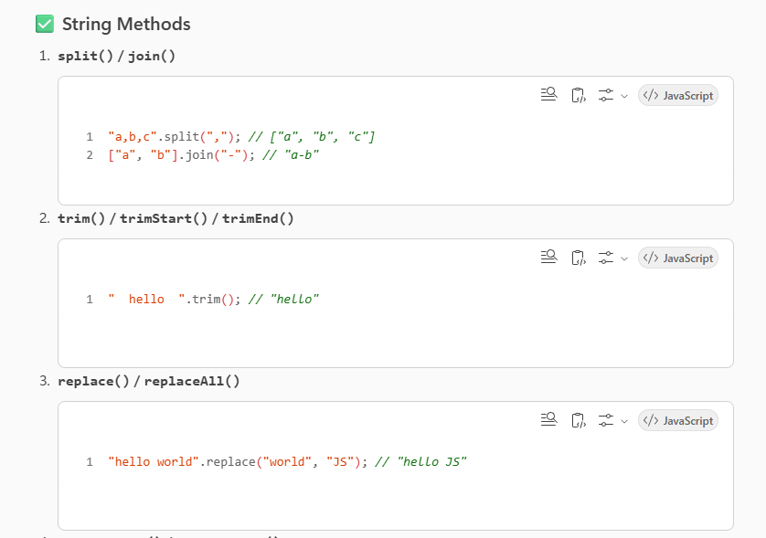
>>charAt(index)
>>charCodeAt(index) → Unicode value

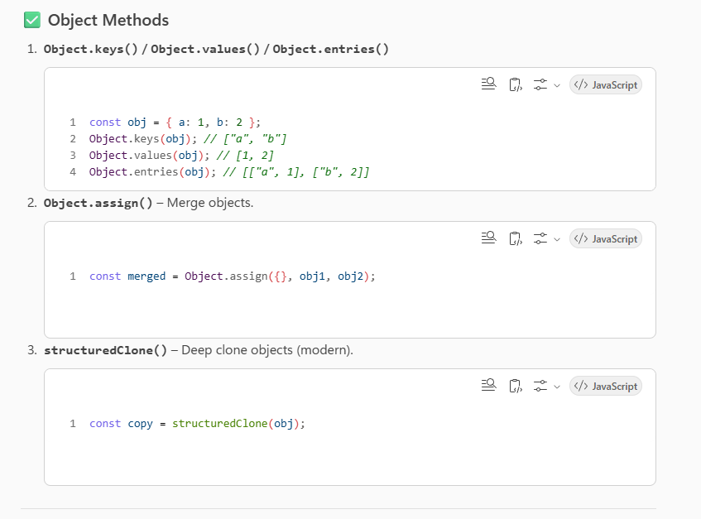
>> Object.groupBy(array, callback) takes an array and a callback that returns the group key for each item. It returns an object whose property names are the group keys and values are arrays of items in that group.

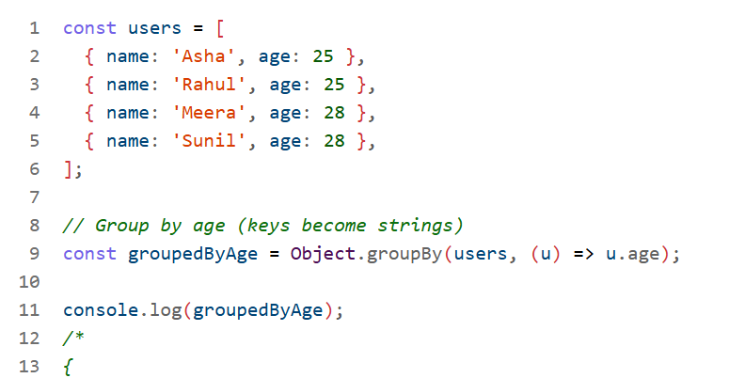

const obj = { a: 1, b: 2, c: 3 };

const sun = Object.entries(obj).reduce((acc, [key ,value])=>{
if(value>1)
acc[key] =value
return acc
},{})

console.log(sun) //{ b: 2, c: 3 }

>>> Object.entries(obj)
const user = { name: "Alice", age: 25 };

for (const [key, value] of Object.entries(user)) {
console.log(`${key}: ${value}`);
}
// name: Alice
// age: 25

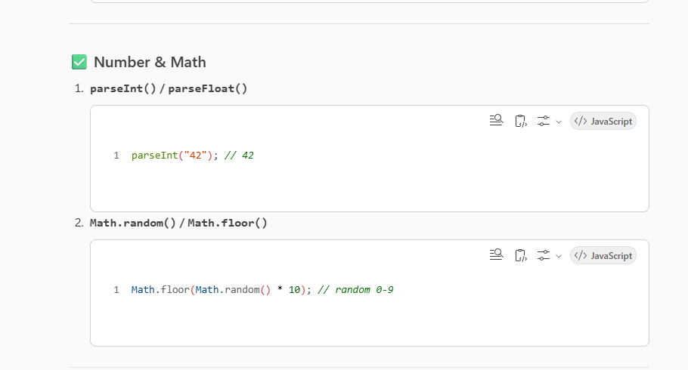
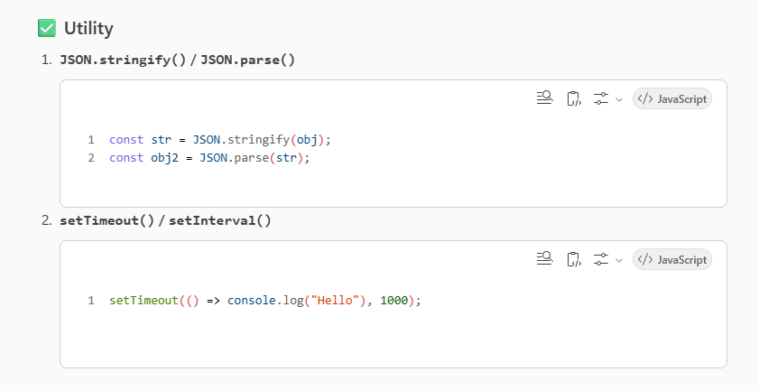
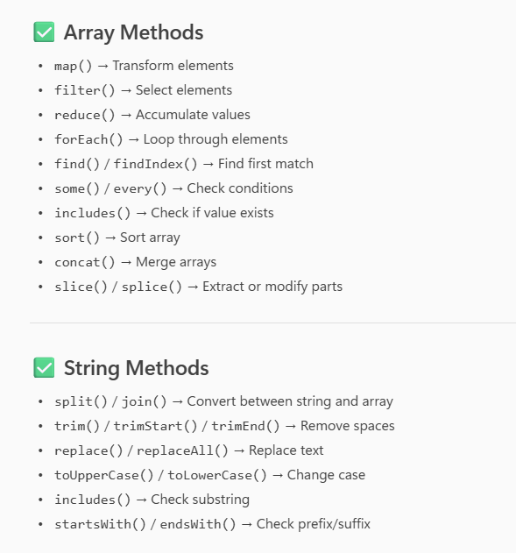
>> str.repeat(3) – to repeat the string
>> flat()
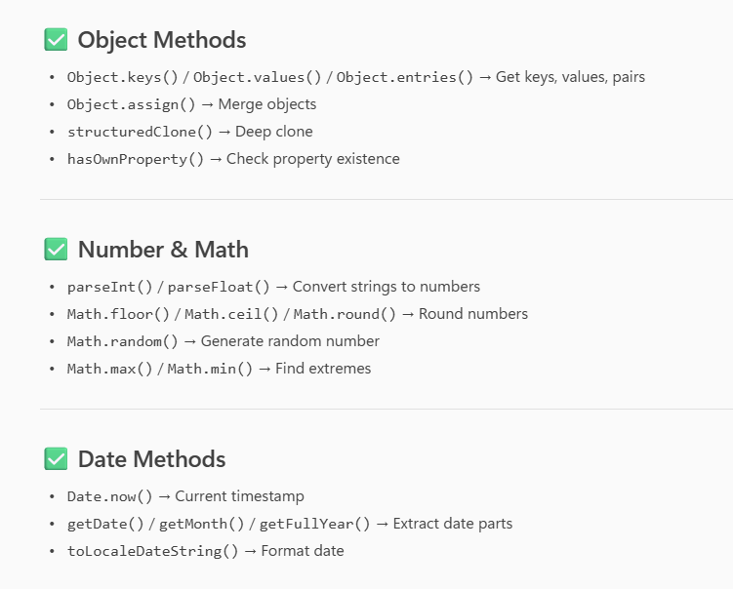
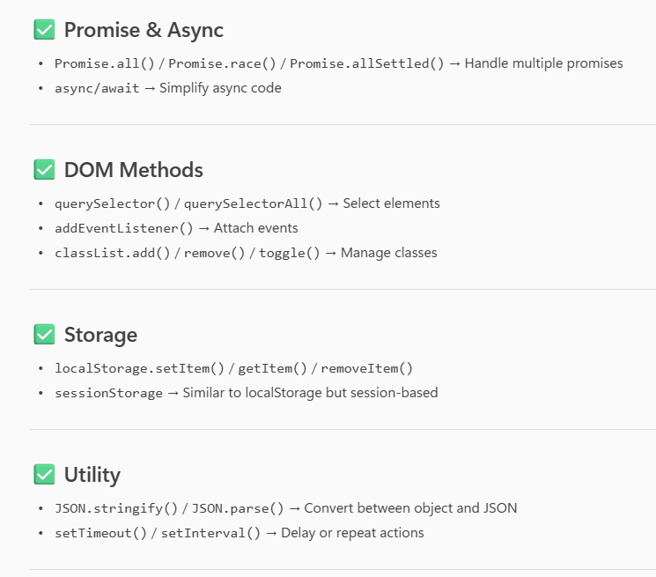
>> short-circuit condition
short-circuit condition refers to how logical operators (&& and ||) evaluate expressions and stop (or "short-circuit") as soon as the result is determined, without checking the remaining conditions.

>> setTimeout (0) take more time promise

>> React Fiber
is the new reconciliation engine introduced in React starting from version 16. It’s essentially a complete rewrite of React’s core algorithm for rendering and updating the UI.
Here’s a breakdown of what it is and why it matters:
What is React Fiber?
- It’s the implementation of React’s reconciliation algorithm, which determines how changes in the component tree are reflected in the DOM.
- Fiber represents a data structure (a linked list of nodes) that allows React to break rendering work into small units and spread them across multiple frames.
Why was Fiber introduced?
- The old algorithm (called “Stack Reconciler”) was synchronous and could block the main thread during large updates.
- Fiber enables incremental rendering, meaning React can pause, resume, and prioritize work. This is crucial for:
>> React Portals
provide a way to render children into a DOM node that exists outside the parent component’s DOM hierarchy.
Normally, React components render inside their parent’s DOM tree. But sometimes you need to render something outside of that—for example:
  - Modals and Dialogs
  - Tooltips and Popovers
